Step 1: Power on Puritan Bennett™ 980 Ventilator & CARE DAQ (DAQ starts automatically after power connected)

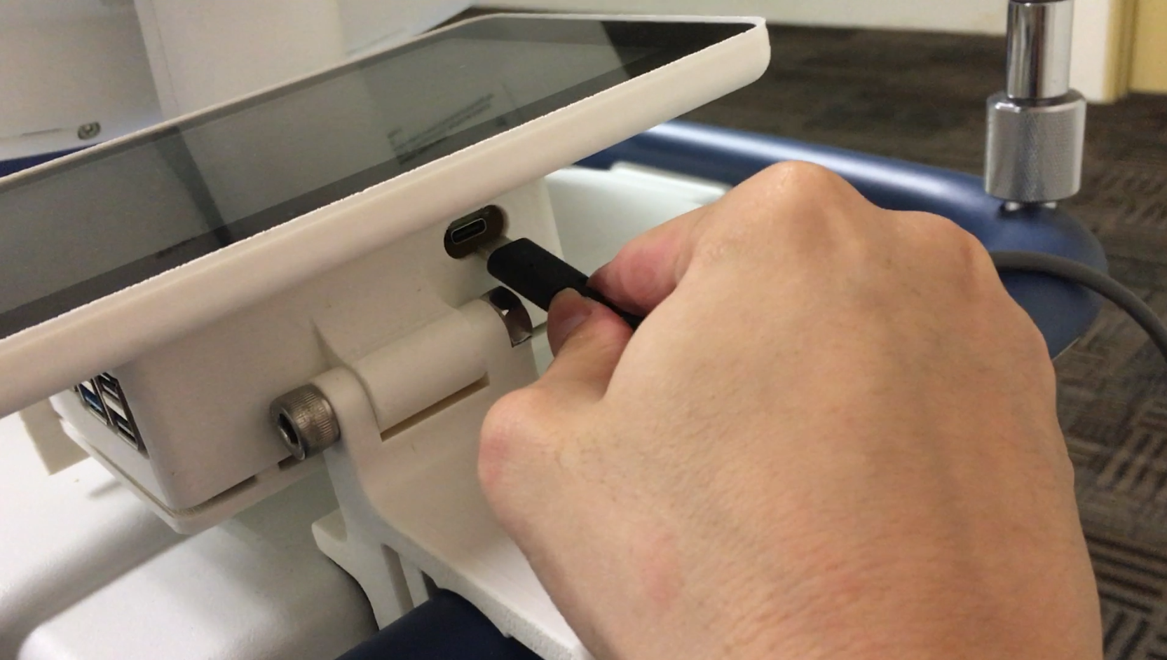

DAQ

Step 2: Connect cables to Puritan Bennett™ 980 Ventilator

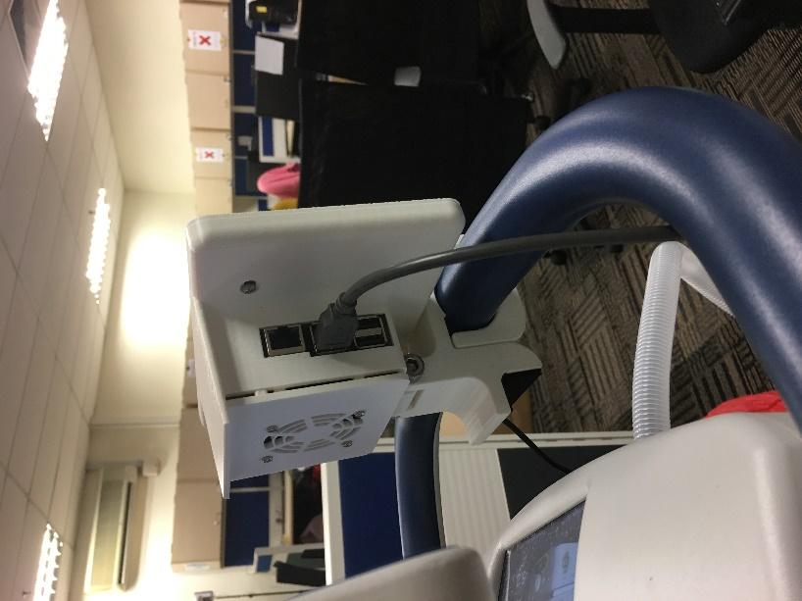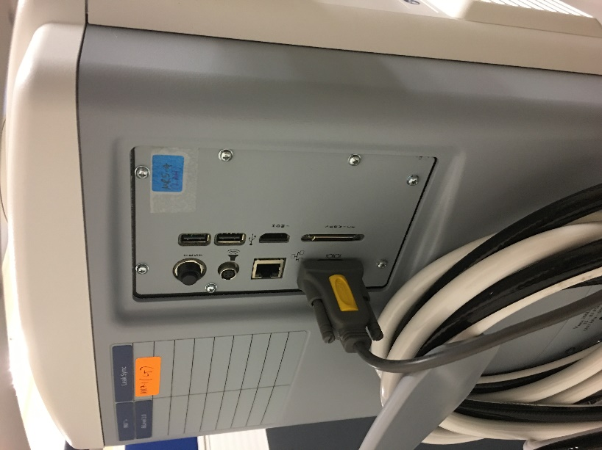

Contact no.

Dr. Chiew : 010-7163710

Step 3: After setting up the hardware, click on the Settings on bottom right

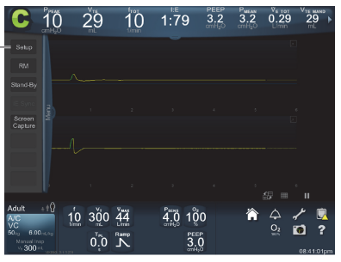

Step 4: Go to Comm Setup1 -> set accordingly2 -> press Accept All3-> press Home4

2

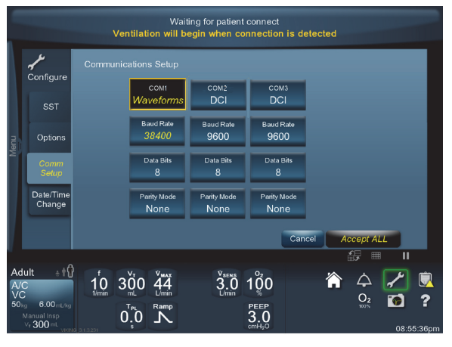

2

**COM 1: Waveforms**

**Baud Rate: 38400**

**Data Bits: 8**

**Parity Mode: None**

1

4

3

Step 5: CARE soft will open automatically when DAQ starts (Double-click CARE

soft iconon desktop if it is not started automatically)

Step 6: Select *“Puritan Bennett 980”* mode.

Step 7: Select patient’s number button, input patient number, and press Confirm.

3

2

1

4

Step 8: Start Collecting Data.

Data collection in progress...

Stop Data Collection:

Step 1: Select Stop button and press Confirm.

2

1

Exit CARE DAQ:

Step 1: Select Exit button and press Confirm.

2

1

Shutdown DAQ:

Step 1: Select  Logo button on top left and press Shutdown.

2

1

Step 2: Select Shutdown. Please wait 30 seconds before unplugging power cable.

